The multiThreshold guide to getting started

multiThreshold is a flexible piece of computer software suitable for measuring many aspects of hearing both in the clinic and in the laboratory. This guide will get you started on three of the most useful measurements: absolute thresholds, frequency selectivity and compression.
This guide assumes that you are much too busy to read manuals and want to get started now. It also assumes that you have already downloaded the software and know what an absolute threshold is.

Absolute threshold measurement
- multiThreshold runs in MATLAB on a PC, so the first thing to do is to launch MATLAB.
- Now move to the folder multiThreshold 1.46 in the MAP1_14 folder. Only you know where you put that folder.
- Run multiThreshold by typing in the command window: run MultiThreshold
- You should now see the experimenter graphical user interface (GUI). Type your name in the ‘Name’ box.
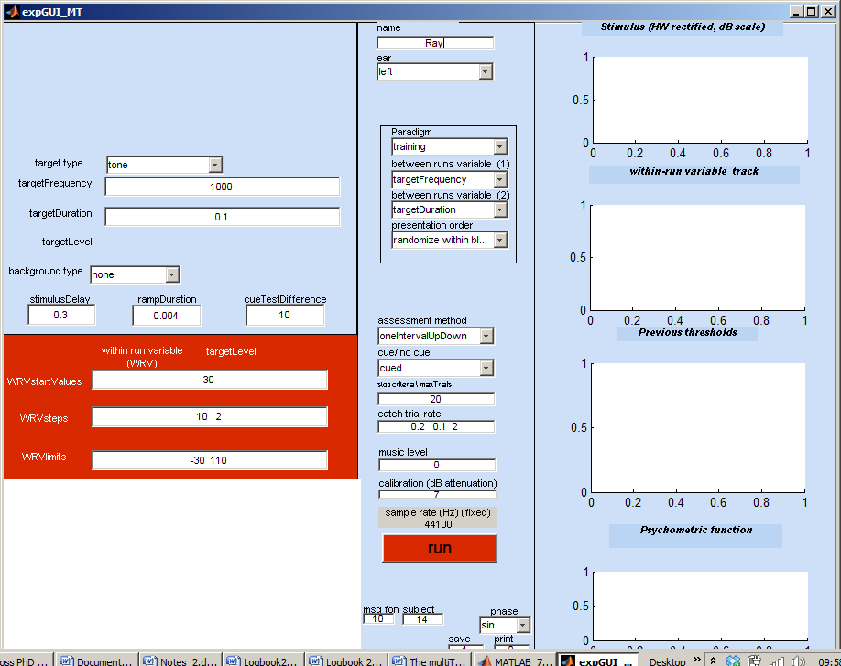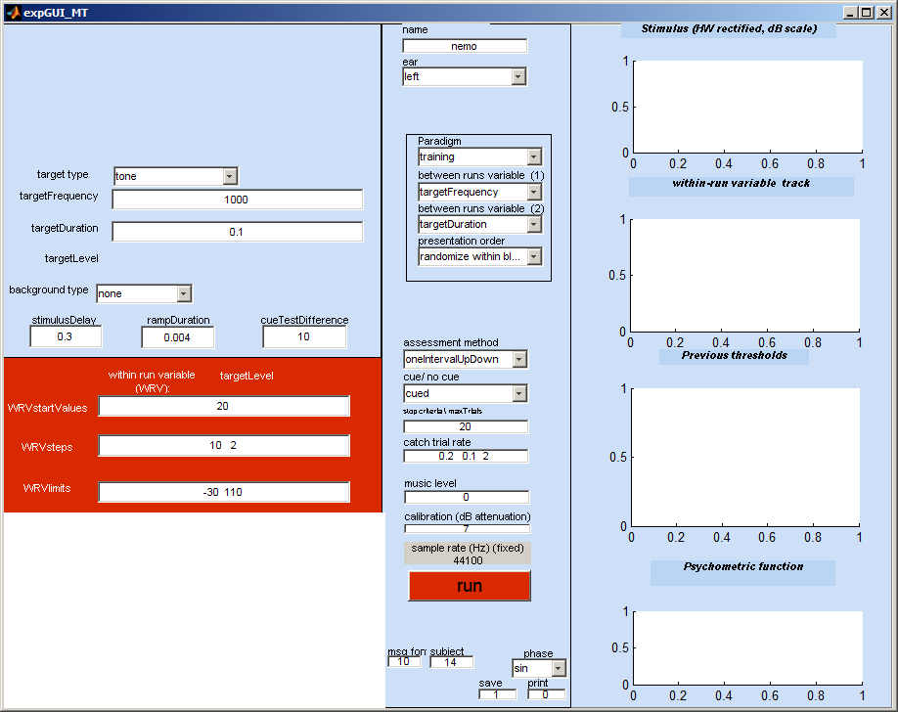
- You are ready to start making measurements. Plug your headphones into the computer headphone socket but before you do this adjust your audio output level to maximum. Your computer will not yet be calibrated to give correct decibel sound pressure levels (dB SPL) but we can still get a general idea of how the software works.
- On start up the GUI is set up in ‘training’ mode. This makes a single absolute threshold measurement at 1 kHz using a 100-ms tone. Put the headphones on.
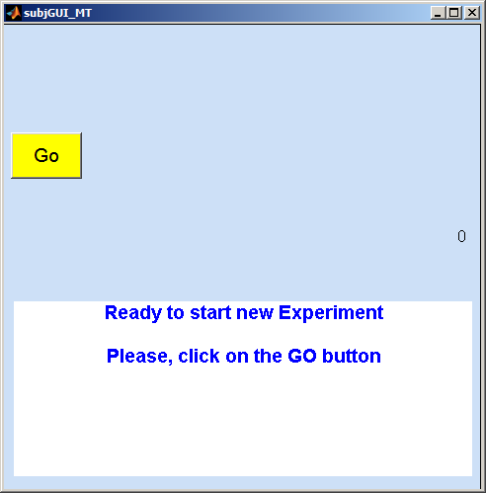
- Click on the red ‘run’ button. A second GUI (called the subject GUI) should appear. Move this box so that you can see both GUIs at the same time. When measuring a client’s hearing the subject GUI should ideally be on a separate screen so that he/she cannot see the experimenter GUI that you are using to control the process. However, this does not matter for the present.
- You are now the patient/ subject/ guinea pig. Click on the yellow ‘Go’ button. Two tones or beeps will be immediately presented over the headphones. After the beeps the GUI will present a number of click boxes
- Click on the box containing the number of clicks you heard. Hopefully, on this occasion, this number will be ‘2’. If you do not hear two beeps you might have a problem with your computer or your computer might be producing beeps that are too quiet to be heard. If the latter is the case you can request louder sounds by increasing the number in the box called WRVstartValues in the red section of the experimenter GUI. By default this is the number ‘30’ which should produce a 30-dB SPL tone. If your computer is not yet calibrated we do not know exactly what level of sound it is producing. We can live with this for the moment by putting a bigger number in the box (say 60) and restarting the run by clicking again on the ‘run’ button.
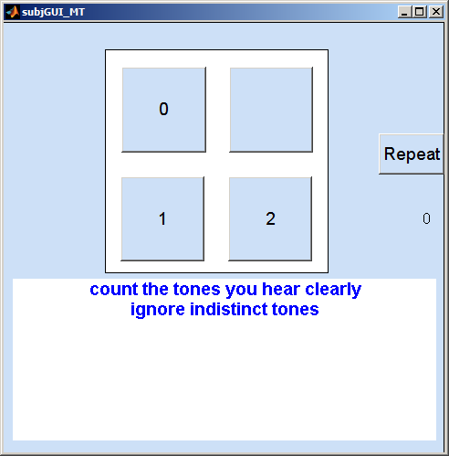
- When you make your first choice by clicking on one of the numbers, the software will soon after generate the next stimulus. Continue responding until the measurements terminate. The measurement proceeds on an up and down basis. If the test tone is heard (button ‘2’ clicked), its intensity will be increased in level on the next trial. If it is not heard (button ‘1’ clicked), its intensity will be decreased in level on the next trial. This up and down process will generate a ‘track’ that is displayed on the experimenter GUI in the second figure down on the right.
- This will continue for a number of trials. After this the software will announce the end of the run by playing ‘tada’ over the headphones. The threshold is then computed as (roughly) the average of the levels of the recent tones heard. This will be displayed in the white panel to the bottom left of the experimenter GUI. A summary of the results and a complete list of parameters will also be printed out in the command window. Here are the first few lines of the summary showing a threshold of 3.4 dB SPL.
Name: Ray  paradigm: training  Ear: left  method: oneIntervalUpDown  date: 19-Sep-2011 10_03_55  thresholds  targetFrequency/ targetDuration  0.1  1000 3.3972 | 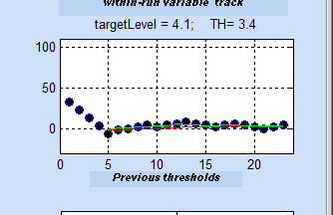
- And that concludes the first threshold measurement.

Notes:
During the measurements, the stimulus presented to the subject is shown graphically on the experimenter GUI at the top right. At this point it is worth introducing some terminology. When there are two tones, the first tone is called the ‘cue’ tone and the second is called the ‘test’ tone. The purpose of the cue tone is to wake the subject up and remind him of what the test tone sounds like. It is exactly the same as the test tone except that it is deliberately made easier to hear. In this paradigm it is easier to hear because it is 10 dB more intense than the test tone which follows. We are not really interested in whether the subject hears the cue tone because we know that he almost always will but we include it in the tone count. Our interest is focussed on the second (test) tone which is quieter. If the subject clicks on the ‘1’ button on a regular trial, multiThreshold assume that he has heard the cue but not the test tone. If he clicks on ‘2’ then he has heard the test tone as well

Sometimes only one tone is played. Trials containing only one beep are called ‘catch trials.

Regular trial | Catch trial
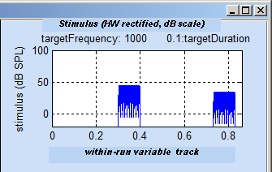 | 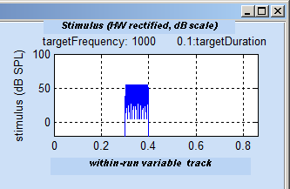

Catch trials are a check that the subject understands the instructions and also that he is not imagining that he hears tones when they are not present (it does happen). The second trial in a run is always a catch trial for a number of reasons. First, it gives an early check that all is well and that the subject can follow the instructions. Second, it reminds the listener that there are trials when the second tone is not present and third, it gives the subject an auditory memory of what a single tone sounds like. Perhaps this is not necessary when counting simple tones but it can be quite helpful in other paradigms when the stimuli are more complex.

Multiple absolute threshold measurements
The guiding principle of multiThreshold is the ‘paradigm’. In the last example, the paradigm was ‘training’. The paradigm is indicated in the pull-down menu with the same name near the centre of the GUI. This guide introduces three other paradigms: ‘absThresholds’, ‘IFMC’ and ‘TMC’. These are otherwise known as ‘absolute thresholds’, ‘tuning curves’ and ‘compression’. In this section we shall concentrate on absolute thresholds.
- Select the paradigm absolute thresholds from the pup-up menu (‘absThresholds’). You will notice that many changes occur on the experimenter GUI. This adjusts all of the parameters for the testing ahead. The six frequencies to be tested should now appear in the ‘targetFrequency’ box. The ‘targetDuration’ is also set (at 0.25 s). The test is ready to begin.
Set paradigm | Note frequencies to be used
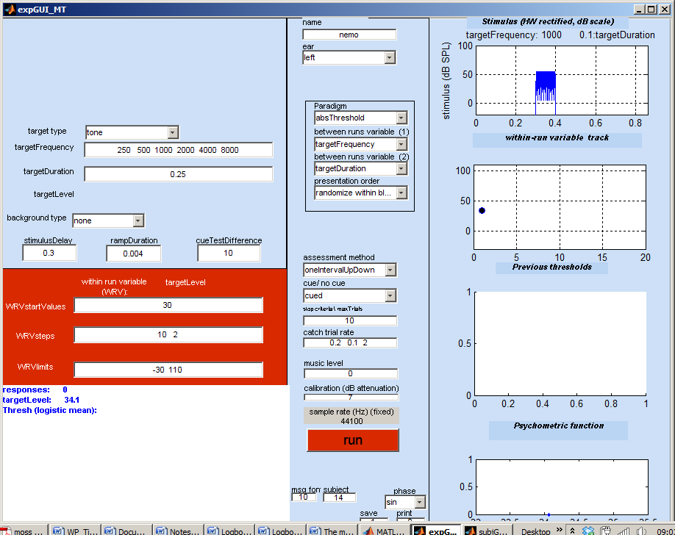

- Click on the red ‘run’ button and the test will start.
- The procedure is the same as described above. The only difference is that a number of threshold measurements will be made in succession. At the end of each threshold measurement, a trill will sound and the subject GUI will revert back to the image with the ‘GO’ button. To move on to the next measurement, you must click on this yellow ‘GO’ button. The ‘tada’ fanfare will signal the end of the series.
- The measurements will be made in random order with respect to frequency but at the end of the series, the experimenter GUI should display all of the thresholds in graphical form and the results will be sorted and printed out in the command window. The command window offers a complete description of the session but the important bits (the thresholds) are printed at both the top and the bottom of the print out.
Thresholds graphical summary. | Command window print out
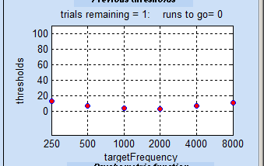 | Name: John doe  paradigm: absThreshold  Ear: MAPmodelSingleCh  method: oneIntervalUpDown  date: 13-Sep-2011 08_26_12  thresholds  targetFrequency/ targetDuration  0.25  250 13.3928  500 7.0523  1000 3.7604  2000 3.4448  4000 7.727  8000 11.3222
- And that concludes the measurement of the absolute thresholds.

Tuning curves
The next paradigm measures frequency selectivity. This is the tendency of the audibility of tones at one frequency to be affected by the presence of tones at other frequencies. To measure this we use a ‘forward masking’ procedure. The patient is asked to listen for a brief 16-ms probe tone that is preceded by another tone usually at a different frequency. If the preceding tone is intense enough and the gap between the preceding and following tone is short enough, it will render the probe tone inaudible.
The measurement goal is to discover just how quiet the preceding tone can be while still preventing the listener from hearing the probe tone. The test is repeated with preceding tones at a range of frequencies. For normal hearing, the interfering tone is most effective when it is close in frequency to the probe tone. When the two frequencies are well separated, the earlier tone is much less effective or even completely ineffective.
The preceding tone is, by convention called the ‘masking tone’. The paradigm to measure masking as a function of frequency separation is called the ‘iso-forward masking’ (IFMC) paradigm. In this paradigm, the probe tone is a fixed level 16-ms pure tone with 4-ms onset and offset ramps. The level of the tone is 10 dB above the patient’s threshold for the tone. The masker is a 100-ms pure tone with a 4-ms onset and offset ramp. The masker switches off 10 ms before the probe tone switches on. The multiThreshold software varies the level of the masker to discover the level of the masker that just masks the probe.
During the test, the patient is asked to listen for the probe tone and ignore the masker. This may take a little getting used to but is simple enough. When the probe is present, it is heard as a ‘click’ or ‘knock’ or ‘rough edge’ at the end of the masker beep.
The masker/probe combination is presented twice. A cue interval is presented first when the ‘click’ should be clearly audible because the masker is less intense. This is immediately followed by the test when the probe tone either is present or is omitted.
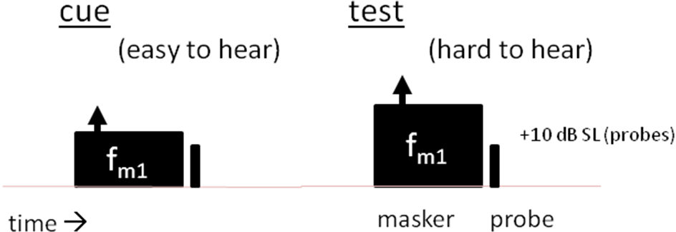 | 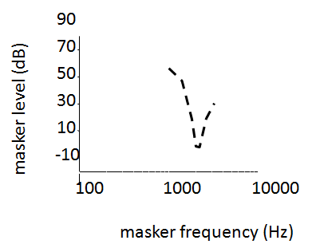

The instruction to the listener is to ‘count the number of intervals when the trailing click is present’. This should be audible during the cue interval so the listener should report at least one trailing click. If the probe is audible in both intervals, the response should be to hit the ‘2’ button on the subject GUI.
The level of the probe tone must be set to 10 dB above the patient’s threshold for the tone. This means that we must begin my measuring the threshold for this 16-ms tone. Once this is done we can begin measuring the tuning curve proper.
- First obtain the absolute threshold for a 16-ms probe tone at 1 kHz; select the ‘absThreshold_16’ paradigm from the paradigm pup-up menu. Notice that the target duration has changes automatically to 0.016.
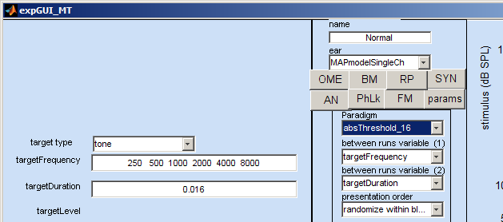
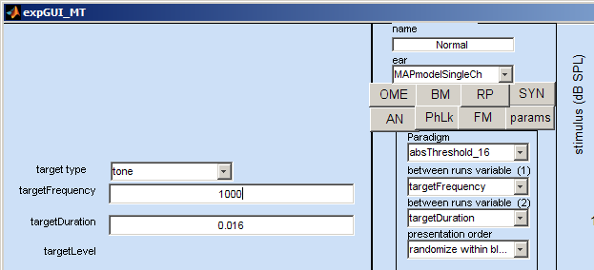
- The paradigm gives 6 frequencies but we only need one (1000 Hz) for this example, so we must delete these frequencies and replace them by a single value (1000).
- Establish the threshold the procedure described earlier. This will be quite quick because the tone is short and the patient is, by now, quite skilled.
- Let us say that the obtained threshold is 6 dB SPL. Note that the threshold for a 16-ms tone will be slightly higher than the 100-ms tone measured in the previous example (because it is shorter). Use this threshold to specify the probe level for the tuning curve measurements below. This is set at 10 dB above threshold and, in this case will be 16 dB SPL. Note this value.
Name: Normal  paradigm: absThreshold_16  Ear: MAPmodelSingleCh  method: oneIntervalUpDown/ withCue  date: 19-Sep-2011 10_15_01  thresholds  targetFrequency/ targetDuration  0.016  1000 5.9888 | 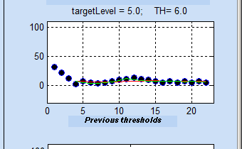
- We can now proceed to the actual tuning curve measurement. Select the ‘IFMC’ paradigm from the paradigm pop-up menu. Many more boxes will appear because this paradigm involves a masker in addition to a probe. The extra boxes give details of the masker characteristics. Fortunately, the software fixes most of them. Make sure that the targetFrequency is 1000. Change it, if it is not.
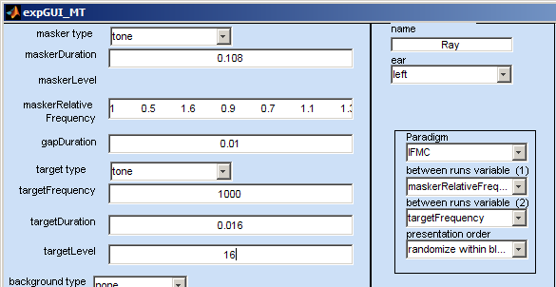
- We are almost ready to go but notice that the targetLevel box contains the mysterious value ‘NaN’. This is MATLAB speak for ‘not a number’. Replace NaN with the required probe level (in this case it is 16, see above).
- Start the measurements by clicking on the red ‘run’ button.
- The subject should click on the yellow ‘GO’ button on the subject GUI to hear the first stimulus.
- This typically begins with quiet maskers which may be inaudible to help the subject concentrate first on the test clicks. The stimulus presented is shown in the stimulus box to the top right of the experimenter GUI. If the listener has understood the instructions, he should hear two probe tones and will respond by clicking on the ‘2’ button. He may hear nothing at all even though the probe tone is above absolute threshold. This may sound like a paradox but it is simply a matter of attention and knowing what to expect. A few repeat trials (click on the ‘repeat’ box) will gradually give the listener the chance to become familiar with what is happening and the problem (if it does occur) should not reoccur.
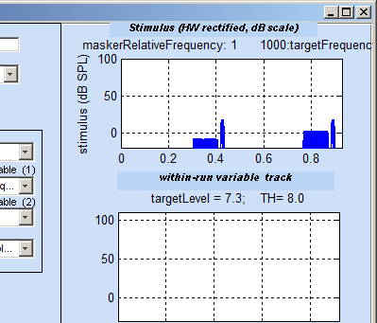
- In the following trials, the masker level is raised or lowered according to the listener’s response. If the test probe is heard, the masker is made more intense. If it is not heard, the masker is made less intense. Remember that the masker is making the probe difficult to hear.
- Catch trials are included and serve the useful purpose of checking that the listener really has understood the instructions. If a probe is reported when none was presented, a red screen appears and the run is aborted. We begin again from the beginning of the run. It is important that the listener only clicks on the ‘2’ button when he is certain that he has heard both probes. If the listener is repeated caught out, either he is not following instructions or does not understand them.
- The measurements will be automatically repeated for different masker frequencies to discover how frequency affects the ability of the masker to mask the probe tone. The subject must click on the yellow ‘GO’ button on the subject GUI to start successive measurements. The frequency and level of the probe remains fixed throughout. The masker frequencies are specified relative to the fixed probe frequency. The relative frequencies are shown in the maskerRelativeFrequency box on the experimenter GUI. These are, by default ; 0.5, 0.7, 0.9 , 1.0, 1.1, 1.3. Multiply these numbers by the probe frequency (1000) to get the actual masker frequencies.
- The measurements should take about 5-10 min. The results are plotted on the GUI and printed out in the command window. For normal hearing, this should form a V-shape; the more remote the masker frequency from the probe frequency, the less it’s masking ability and the greater the level required to prevent the probe from being heard.

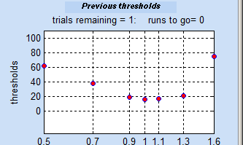 | Name: John Doe  paradigm: IFMC  Ear: MAPmodelSingleCh  method: oneIntervalUpDown  date: 13-Sep-2011 09_26_14  thresholds  maskerRelativeFrequency/ targetFrequency  1000  0.5 68.2657  0.7 50.8073  0.9 23.2154  1 21.0801  1.1 18.6945  1.3 30.8803  1.6 76.5877

- If you are reasonably sure that your hearing is normal but you do not obtain a V-shape, do not despair because this procedure requires a little practice. When testing a patient, a little encouragement may be in order because the task is so unfamiliar. A useful tip is to click on the ‘2’ button only when absolutely sure that the trailing probe has been heard. When unsure, always choose the ‘0’ or ‘1’ button. Some listeners (particularly those with some psychophysical training) persist in clicking on ‘2’ even during catch trials when no probe is present. This either means that they do not understand the distinction between the probes and the ‘distracting beeps’ or that they are trying too hard to hear something. Repeating the instructions or a short discussion will normally clear up the problem.
- The procedure can now be repeated using different probe frequencies. Note that you will need to measure the threshold of the probe tone afresh for each probe frequency used.

Compression
The normal ear has a natural tendency to compress the level of the sounds it is processing. In the mid-level region, this can be as great as 0.2 dB/dB. In some impaired hearers, this compression can is absent so that the internal representation of the sound grows at the same rate as the sound itself. It is time-consuming to put a numerical estimate on the amount of compression and most methods are controversial. However, multiThreshold can measure it to the extent that it can be compared with normal hearing.
The technique is similar to the tuning curves method described above and uses a masker followed by a test probe. However, in this case the masker and the probe always have the same frequency. What changes is the time interval between the two. For the tuning curve, the gap was fixed at 10 ms. For the compression estimate, the gap varies between 10 and 90 ms.
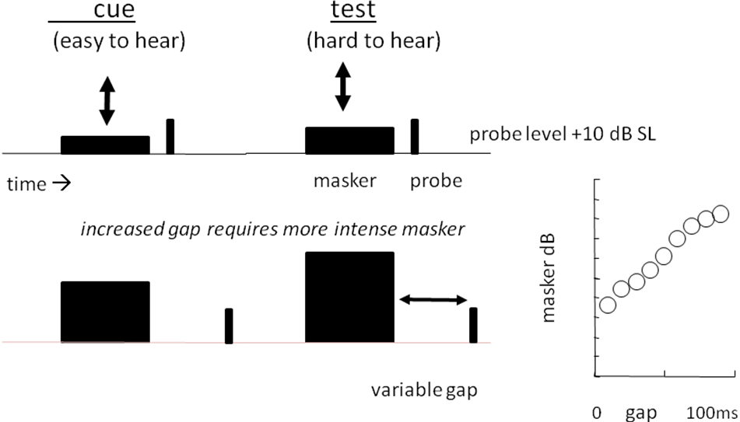

As the gap increases, the masker will need to increase in level to maintain its ability to prevent the test probe from being heard. The rate at which it increases is indicative of the amount of compression. A steep rise indicates that the masker is being compressed. If the rise is shallow, the masker is not being compressed and a small increase in the masker is producing a large internal change, enough to mask the probe.
- Select ‘TMC’ from the paradigm pop-up menu.
- The probe level used in this test is the same as for the tuning curves, i.e. 10 dB above the absolute threshold for the probe. If we measure compression at 1-kHz, we can use the same probe level (18 dB SPL) as we did in the previous example. Put probe level in the targetLevel box. Make sure that the targetFrequency is 1000. If not, change it.
- The measurements proceed as for the tuning curve. The listener counts the number of trailing clicks. A number of measurements are made (at different gaps). The listener must click on ‘GO’ between each run.
- When all of the measurements are complete, the masker levels are plotted against gap duration. Good compression is indicated by a steep rise. In this case a rise of 60 dB can be seen. For some hearing impaired listeners, the rise can be as small as a few dB (<10) so the difference is quite marked.
- Warning. Impairment is not necessarily the explanation if a shallow slope is obtained. Other explanations are possible. Compression is only observed in the mid range where ‘mid range’ is poorly defined. However it can be seen in the figure below that the rise between gaps 10 and 30 ms is very small (only 1 dB). This is because the masker level is too low to show the effect. The region close to absolute threshold shows no compression even in normal hearers.
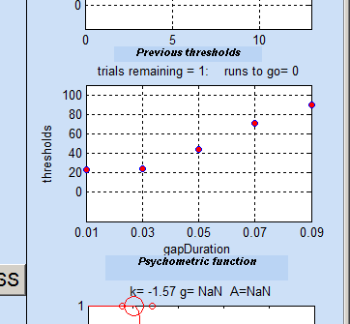 | Name: John Doe  paradigm: TMC  Ear: MAPmodelSingleCh  method: oneIntervalUpDown  date: 13-Sep-2011 11_54_20  thresholds  gapDuration/ targetFrequency  1000  0.01 22.83  0.03 23.8216  0.05 44.1472  0.07 70.791  - 89.4251
- The procedure can now be repeated using different probe frequencies. Note that you will need to measure the threshold of the probe tone afresh for each probe frequency used.

Calibration
Calibration is always tricky. The experimenter GUI has a box marked calibration. Adjust the calibration by entering an appropriate value (in decibels). The output from multiThreshold is adjusted down by the value entered here. The required calibration depends on many things including the computer sound card and the headphones used. More information and advice is given in the technical manual for multiThreshold.

